**Project Design Phase**

**Problem – Solution Fit Template**

|  |  |
| --- | --- |
| Date | 27 June 2025 |
| Team ID | LTVIP2025TMID34066 |
| Project Name | SmartSDLC – AI-Enhanced Software Development Lifecycle |
| Maximum Marks | 2 Marks |

**Problem – Solution Fit Template:**

The Smart SDLC Assistant solves common developer issues like bug fixing, code generation, and requirement transformation using IBM Granite LLM. It fits developer needs by integrating directly into their workflow, saving time and reducing errors. The assistant builds trust by solving frequent technical problems and streamlines communication between teams. This boosts productivity and makes software development faster and smarter.

**Purpose:**

* Solve complex problems in a way that fits the state of your developers
* Succeed faster and increase your solution adoption by tapping into existing mediums and channels of behavior.
* Accelerate productivity by providing an AI-powered solution that understands developer behavior and integrates smoothly into their workflow.
* Build trust and efficiency by solving recurring developer challenges with contextual support from a generative AI assistant.

**Template:**

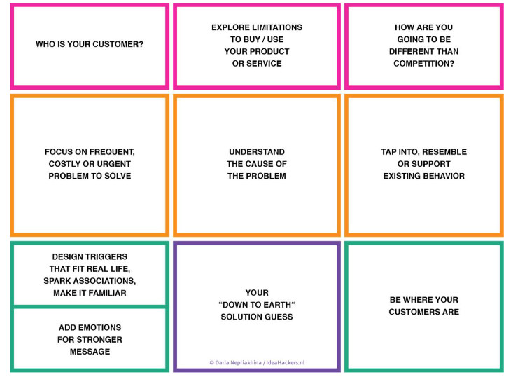

References:

1. <https://www.ideahackers.network/problem-solution-fit-canvas/>
2. <https://medium.com/@epicantus/problem-solution-fit-canvas-aa3dd59cb4fe>